**UNIX I/O**

**LAB # 06**



**Fall 2022**

**CSE302L System Programming Lab**

Submitted by: Maaz Habib

Registration No.: **20PWCSE1952**

Class Section: **C**

“On my honor, as student of University of Engineering and Technology, I have neither given nor received unauthorized assistance on this academic work.” Student Signature: ______________

Submitted to:

**Engr. Abdullah Hamid**

Sunday, December 4st , 2022

**Department of Computer Systems Engineering**

**University of Engineering and Technology, Peshawar**

**Lab Objective(s):**

• Understand and implement read, write, open, close and unlink function calls.

**Task # 01:**

**Write a program for parallel file copying using multiple processes.**

**Code:**

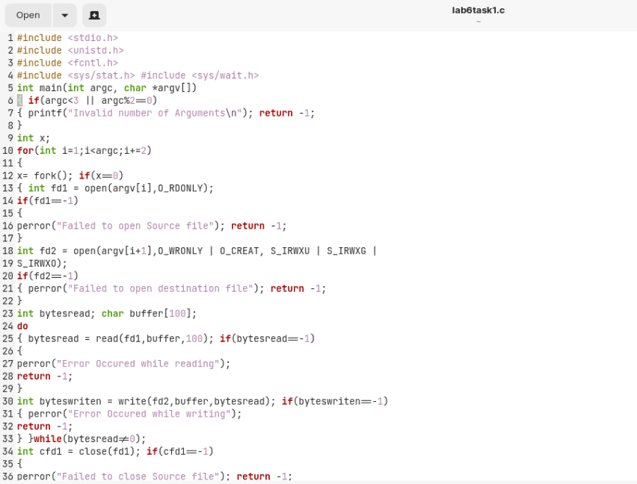

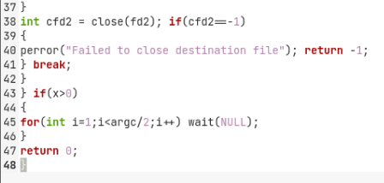

**Output/Results:**

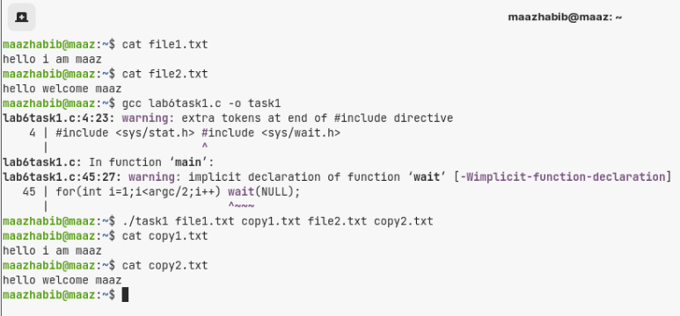

**Task # 02:**

**Implement “Cat” utility.**

1. **Cat**
   1. **Src: STDIN_FILENO**
   2. **Dest: STDOUT_FILENO**
2. **Cat file1.txt**
   1. **Src: file1.txt**
   2. **Dest: STDOUT_FILENO**
3. **Cat f1.txt > f2.txt**
   1. **Src: f1.txt**
   2. **Dest: f2.txt**

**Code:**

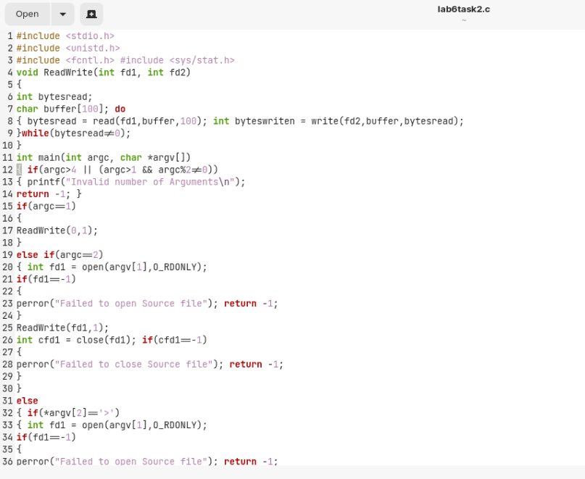

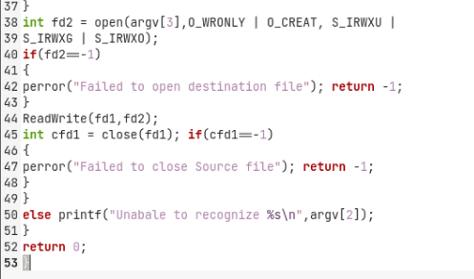

**Output:**

